Mr. Javid Ahmad Baba
Workshop Bearer

Subject: Explanation Required for not reporting for your assigned duties.
You were assigned duties for today on 26-08-2025.However you haven’t reported for your duties as per the report from the Incharge. This unauthorized absence is a grave breach of the attendance and leave policies, which strictly require all employees to obtain prior approval for any absence.
You are hereby directed to submit a comprehensive written explanation for non-reporting to your duties within two (2) calendar days from the date of this notice. Your explanation must clearly detail the reasons for your absence.
Be informed that failure to provide a satisfactory explanation within the stipulated two-day period will result in immediate and severe disciplinary action, as per the established rules and regulations.

No: KGP/Estt/2025/690-691
Dated:26-08-2025
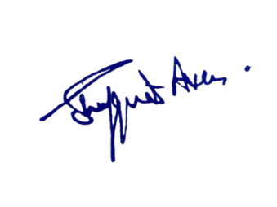

Principal
Kashmir Government Polytechnic College
Srinagar

Copy to the:
1.Accounts Assistant with the direction to stop the salary of the official till further orders.

